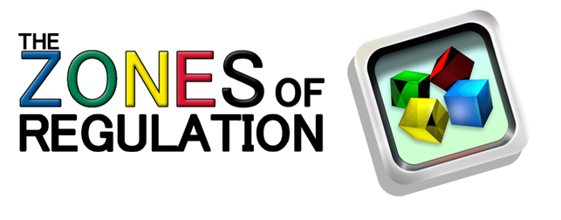

Leah Kuypers, author of the book The Zones of Regulation will present an introduction to the Zones of Regulation along with strategies for implementation for more experienced users.

Date: March 27, 2018

Time: 5-8pm

Location: The Great Room, Washington Technology Magnet

1495 Rice St., St. Paul, MN 55117

Audience: Licensed special education staff

How to Register: St. Paul Schools employees login into PDexpress AND complete the registration on the link: <http://metroecsu.myquickreg.com/register/event/>

Enrollment is limited to 300 people

A blue map of Minnesota containing white numbers of other regions  and a red area representing the metro area, or Region 11.

Funding for this workshop is made possible with a grant from the MN Department of Education. The source of the funds is federal award Special Education - Programs to States, CFDA 84.027A AND CFDA 84.173 Special Education-Preschool Grants and 84.181 Special Education Grants for Infants and Family.